# EXPERIMENT NO.:04

Date of Performance:

Date of Submission:

Aim: Structured Data Flow Analysis

Software Used: Star UML

Theory: Structured Analysis is a development method that allows the analyst to understand the system and its activities in a logical way.

It is a systematic approach, which uses graphical tools that analyze and refine the objectives of an existing system and develop a new system specification which can be easily understandable by user.

It has following attributes −

* It is graphic which specifies the presentation of application.
* It divides the processes so that it gives a clear picture of system flow.
* It is logical rather than physical i.e., the elements of system do not depend on vendor or hardware.
* It is an approach that works from high-level overviews to lower-level details. Structured Analysis Tools

During Structured Analysis, various tools and techniques are used for system development.

They are −

* Data Flow Diagrams
* Data Dictionary
* Decision Trees
* Decision Tables
* Structured English
* Pseudo code

Data Flow Diagrams (DFD)

It is a technique developed by Larry Constantine to express the requirements of system in a graphical form.

* It shows the flow of data between various functions of system and specifies how the current system is implemented.
* It is an initial stage of design phase that functionally divides the requirement specifications down to the lowest level of detail.
* Its graphical nature makes it a good communication tool between user and analyst or analyst and system designer.
* It gives an overview of what data a system processes, what transformations are performed, what data are stored, what results are produced and where they flow.

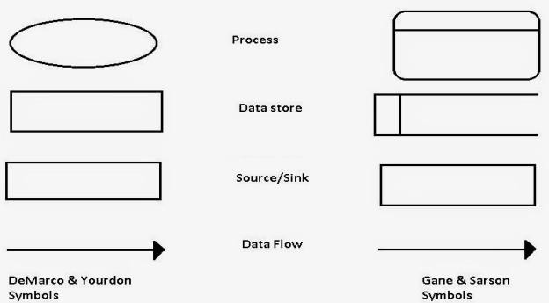

Used Case Diagram

In the Unified Modeling Language (UML), a use case diagram can summarize the details of your system's users (also known as actors) and their interactions with the system. To build one, you'll use a set of specialized symbols and connectors. An effective use case diagram can help your team discuss and represent:

* Scenarios in which your system or application interacts with people, organizations, or external systems
* Goals that your system or application helps those entities (known as actors) achieve
* The scope of your system

UML use case diagrams are ideal for:

* Representing the goals of system-user interactions
* Defining and organizing functional requirements in a system
* Specifying the context and requirements of a system
* Modeling the basic flow of events in a use case

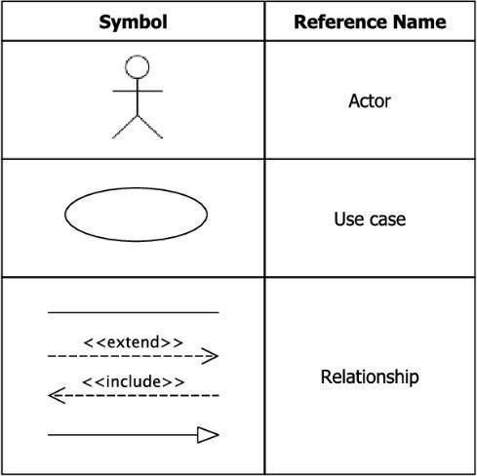

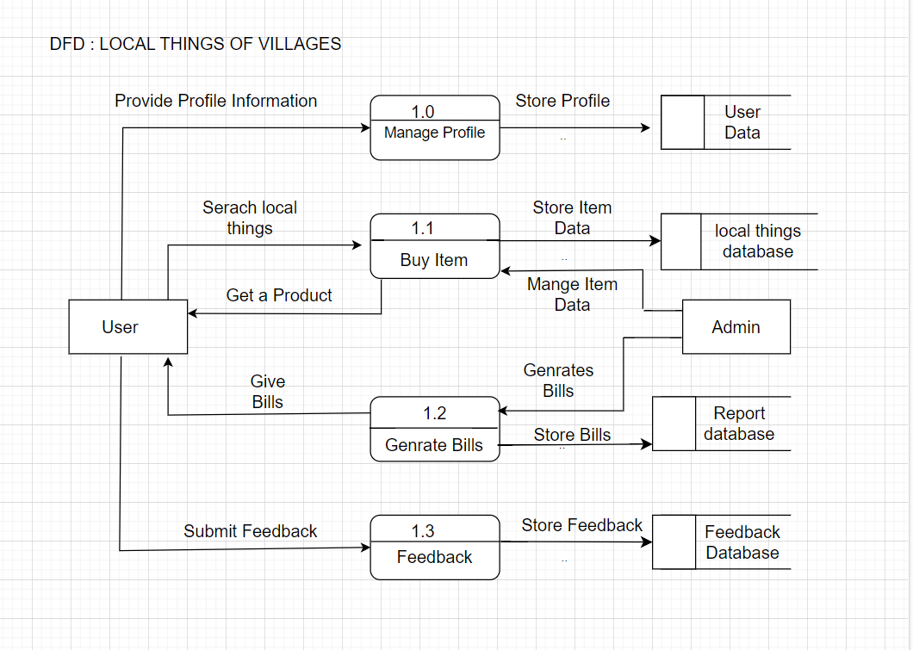

Used Case Diagram:

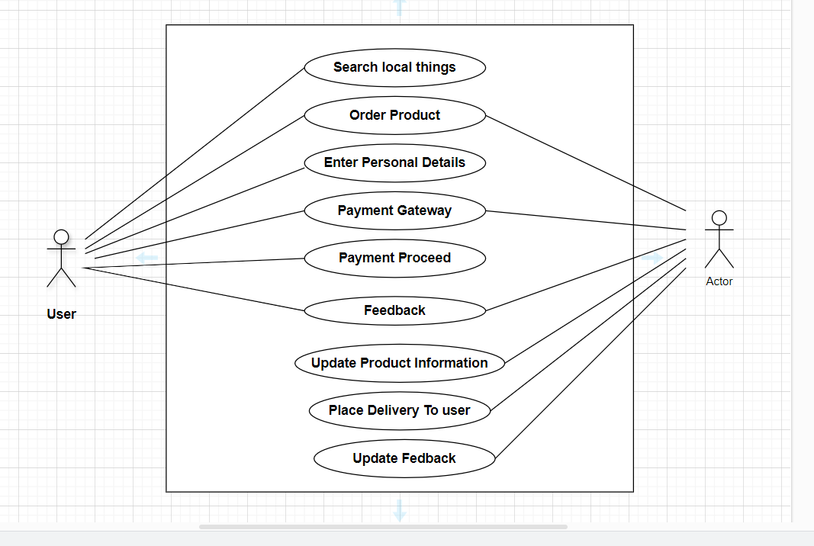

Hence we analyzed successfully the data flow.

# Sign and Remark:

|  |  |  |  |  |
| --- | --- | --- | --- | --- |
| R1 | R2 | R3 | Total Marks | Signature |
| (5) | (5) | (5) | (15) |  |
|  |  |  |  |